
The Secretariat of the Local Medical Committees for
Berkshire, Buckinghamshire & Oxfordshire
Mere House, Dedmere Rd, Marlow, SL7 1PB
Tel: 01628 475727
Fax: 01628 487142
Chief Executives Dr Matt Mayer & Dr Richard Wood
Chair Dr Simon Ruffle
Web: http://www.bbolmc.co.uk
Email: richard.wood@bbolmc.co.uk

11 May 2023
DRAFT Instructions for OPEL Platform Registration and Use

Setting Up The EMIS Searches

- Ensure your EMIS is running the correct search version (v1.4)

- Email assistance@bbolmc.co.uk if you do not have this.
- Set-up the search to run weekly on EMIS. Regardless of which day of the week you choose to run it on, it will always collect data from the preceding week Monday-Sunday.

- If not done so already, install the EMIS search in EMIS: This only needs to be done once.
- Open EMIS “Population Reporting”.
- Add a folder for the searches – for example “BBOLMC”
- If you have a previous version of our search folder , right-click on it and delete from your BBOLMC folder.
- Click “Import”, you should see the following dialog:
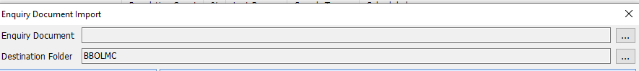
- Use the three dots to the right of “Enquiry Document” to import the file “BBOLMC workload reporting v1.4.xml” into your BBOLMC folder.

- Click “OK” and open the “BBOLMC workload reporting v1.4” folder.
- You should see the “1 Report, all searches” audit report (shown on the right).
- Right click and select “Properties”.
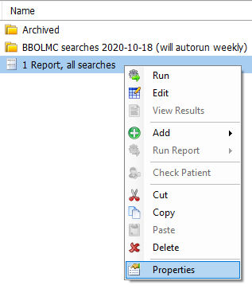
- Enable scheduling to run the search weekly, with suggested settings shown below. Save and close.

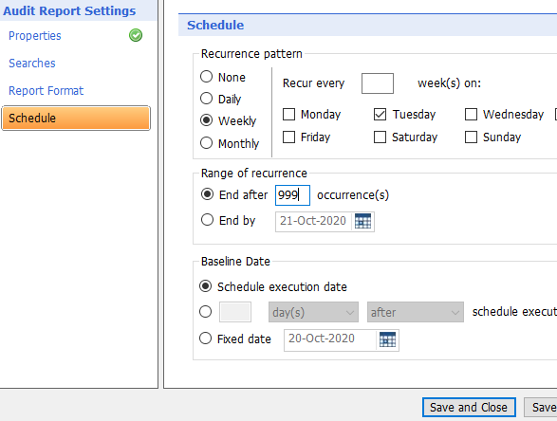
1
- That’s it! Your workload audit report (and all underlying searches) will now run weekly.

- Export the search result weekly, ready for upload to the OPEL Platform
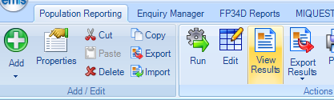
  - Have a regular staff member / diary reminder to action this weekly.
  - The day after your searches have run (e.g. Wednesday), Export the results (to an EXCEL file, not CSV or other format). To do this you have to click “view results” (not “Export results”), then Export. Select the export format ( “Excel”). Save it to wherever you want on your computer.
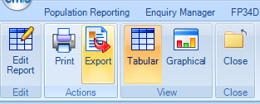
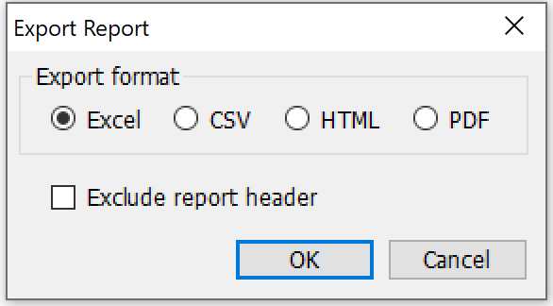

Registering on the OPEL Platform

This only needs to be done once.
- If you have not done so already, register on the OPEL platform

  - To do this, you will need to use the registration link sent to you by BBOLMC. Email richard.wood@bbolmc.co.uk if you do not have it
  - Click on it. It will open up a registration page in your browser:

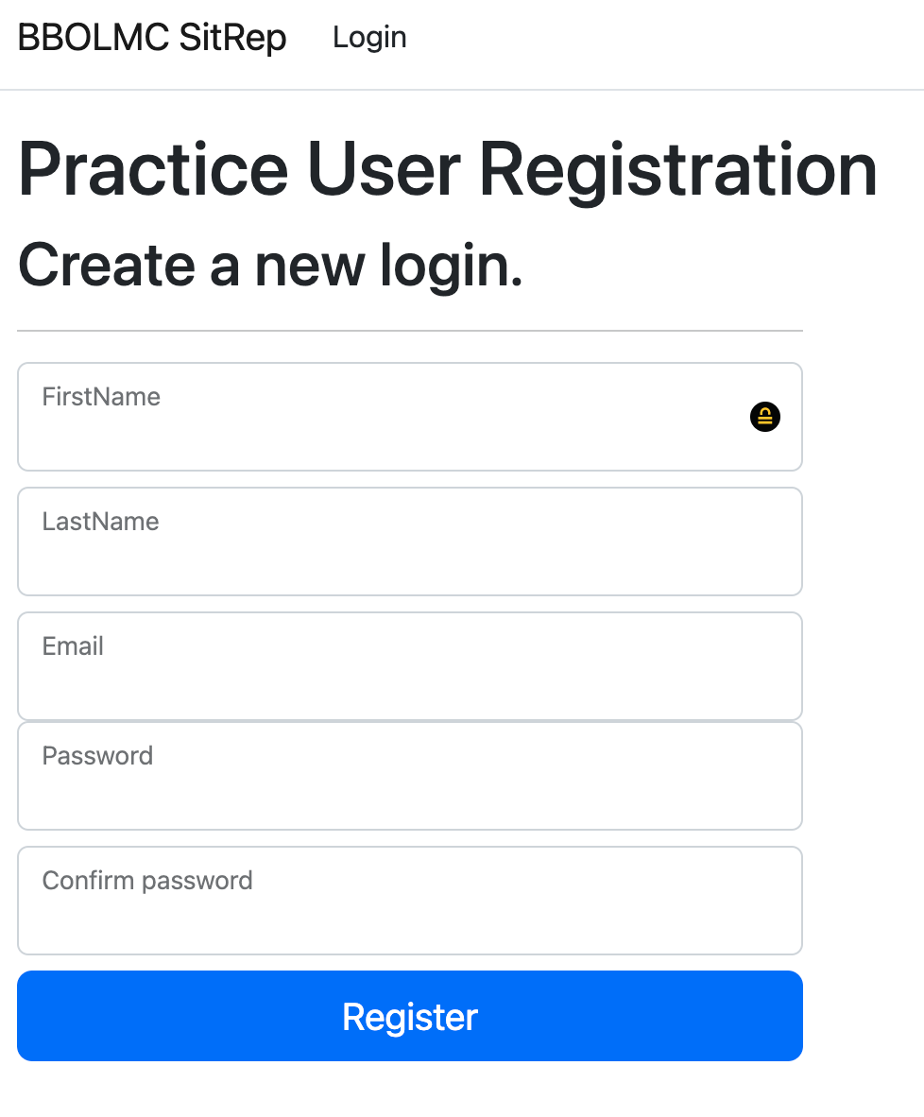

  - Fill in your own name (The registration link will automatically know which practice you are), the login email address and password you want to use. Please use a novel password – not one you use for other purposes, such as your email account login. This is good practice to limit problems for you in the very unlikely event of a data breach.
  - Once done, click register. The system will send a confirmation link to your email address for you to click on to confirm (this may take several minutes!). Check your spam folder. Click on it. If you see a screen advising a security check for malicious software if in progress, give it a minute or so, then click on the link again. Then you’re done.
  - You can use the same link to have as many practice users as you like. But, be careful – you can only submit data once, second submissions for a given week will not be captured. At the time of writing, we are working in the capability to for allowing a user to re-submit data for a given week which will over-write previously submitted data for that week.

- Save the platform link for login purposes.
https://sitrep.bbolmc.co.uk/
Write down your login and password somewhere safe!

Submitting Data To The OPEL Platform

- On the welcome screen, click on “Submissions”

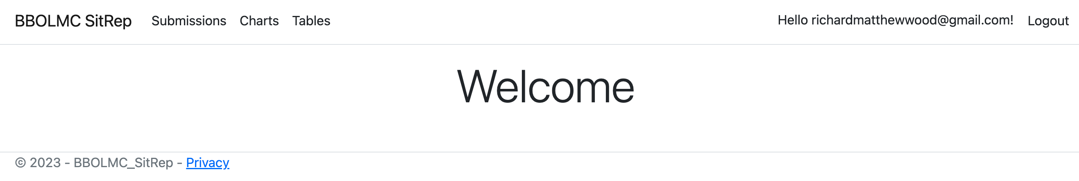

- Click on “Upload Submission”
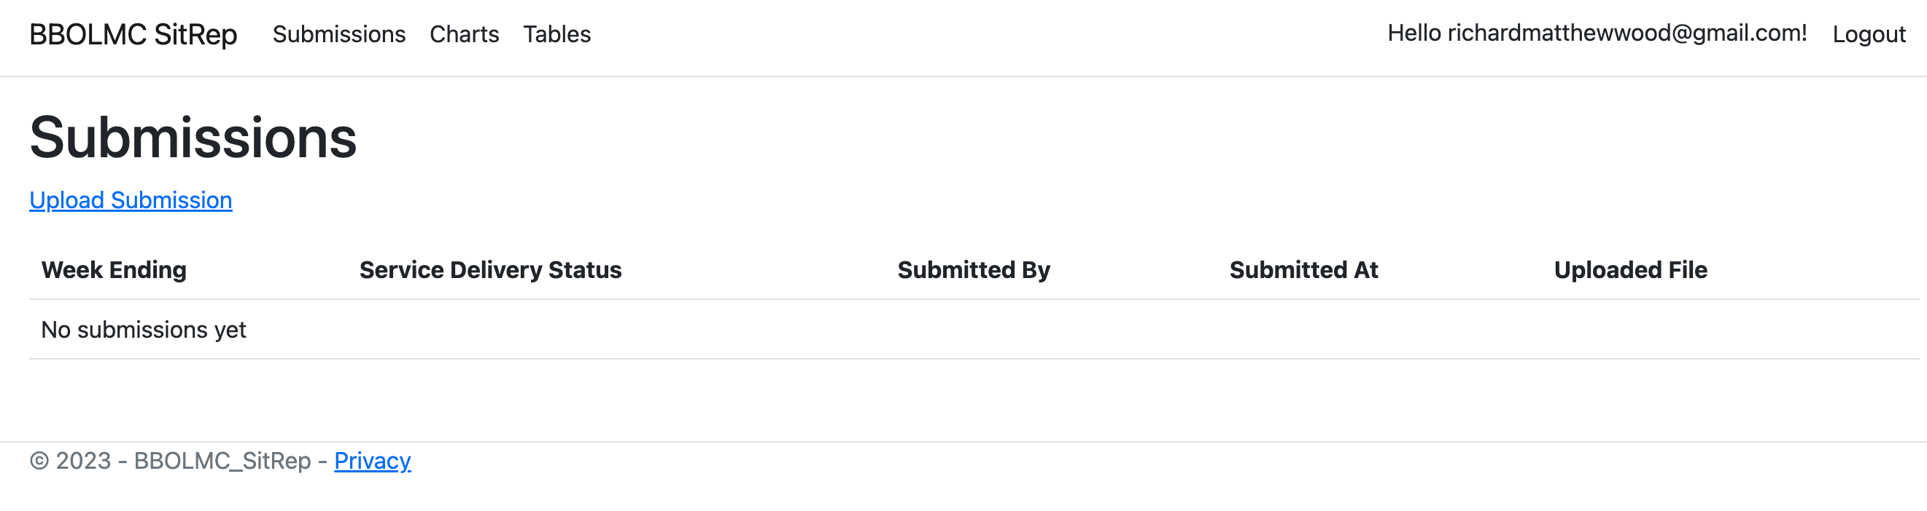
- Here, you upload the excel output of the EMIS search you saved on your desk top (section A.3 above).

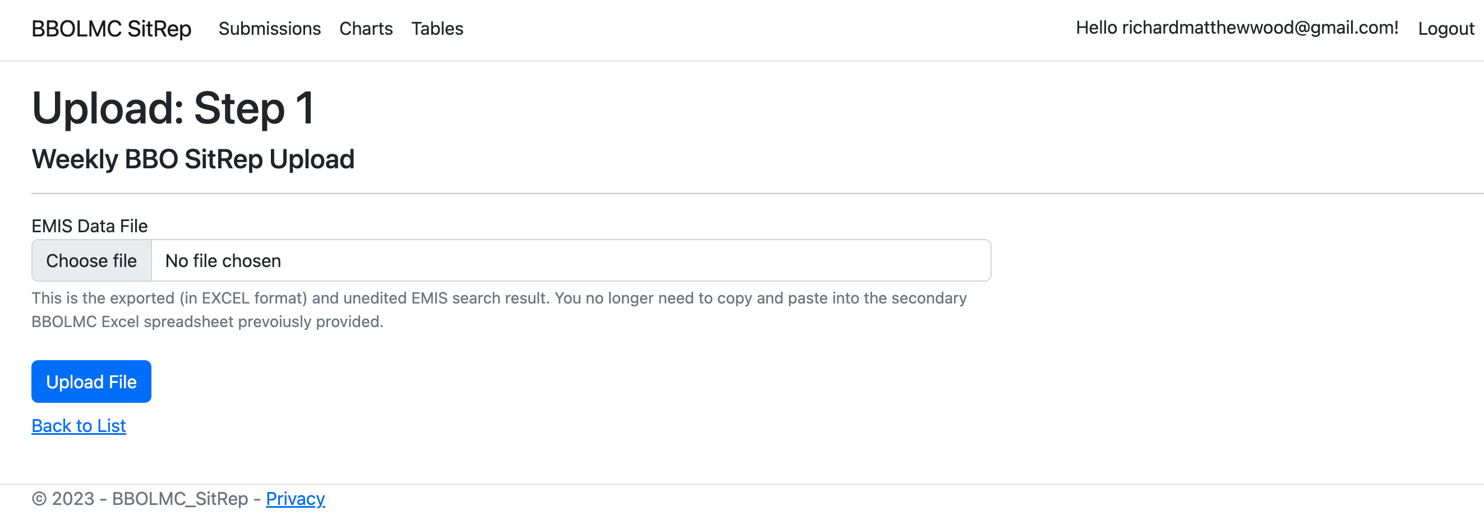

- The platform will automatically recognise your practice, the week your search pertains to.
- Now you need to enter 4 items of data yourself:
Be careful – you can only submit data once, second submissions for a given week will not be captured. At the time of writing, we are working in the capability to for allowing a user to re-submit data for a given week which will over-write previously submitted data for that week.

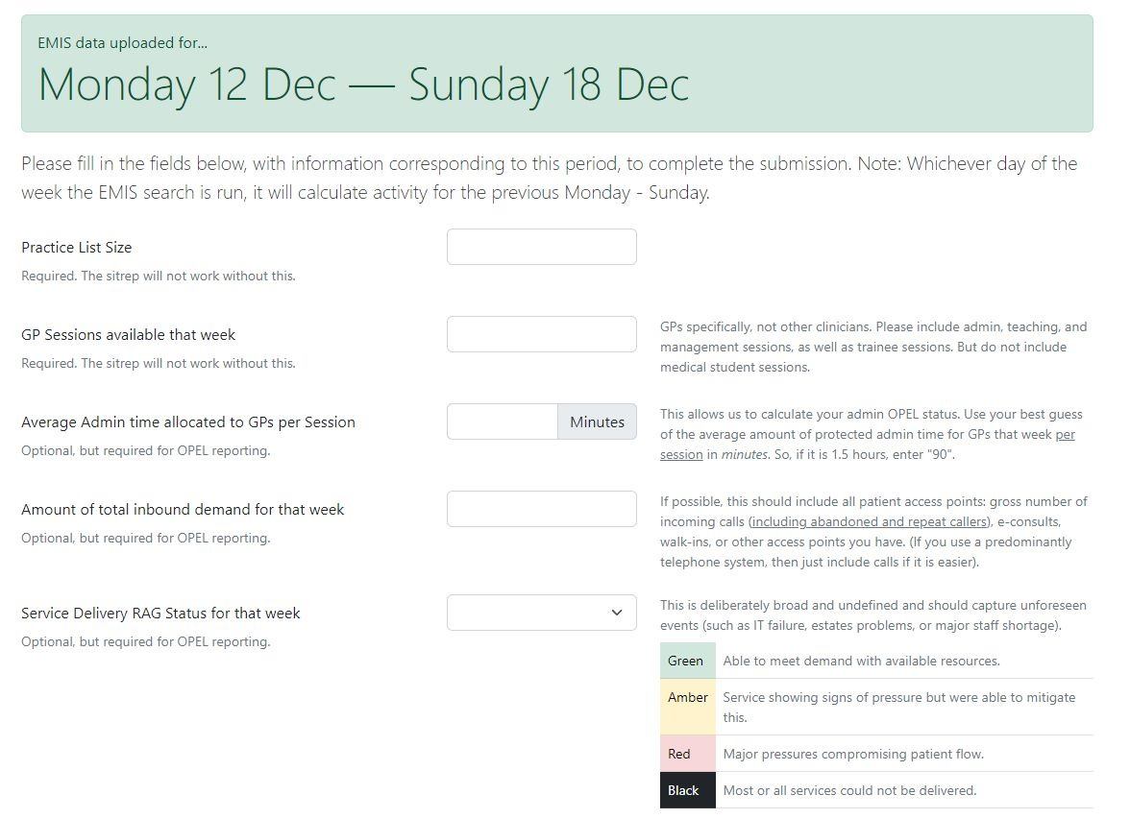
  - Your practice list size. None of the entire project will not work without this – it is critical. Be as accurate as you can, and list sizes flux a lot in some areas.
  - The Number of GP sessions you have in your practice for the week pertaining to the search. None of the entire project will not work without this – it is critical. GPs specifically, not other clinicians. Please include locum, admin, teaching, and management sessions, as well as trainee sessions. But do not include medical student sessions”. Please enter a number only, not letters, no spaces.
  - Number of total inbound demand for that week. If you don’t submit this, you can still see your practice activity overtime in the relevant chart, but the OPEL scoring will not work without it. This is normally the total number of inbound calls your practice had that week (available in your advanced telephony platform. If the platform only gives you monthly calls, divide that number by 4.35, which is the average number of weeks in a month). Use the gross incoming calls (NOT answered calls; do not ignore repeat callers). If you use e-consults, you can add that number to the calls. You may also wish to add any walk-ins, NHS 111 bookings, and any other demand points you have. Its up to you. But add them all together into a single number. Please enter a number only, not letters, no spaces.
  - The average number of minutes of admin time allocated to GPs per session that week. If you don’t submit this, you can still see your practice activity overtime in the relevant chart, but the OPEL scoring will not work without it. Enter in minutes (so, 1.5 hours = “90”). Please enter a number only, not letters, no spaces. If GPs vary in their allocated admin time, work out your average as best you can. Include any time devoted to clinical admin. This is normally admin slots in your session, and perhaps management time (where it is often absorbed by clinical admin), but not teaching time. Give it your best guess if this is too faffy, but the more accurate the better.
  - Service Delivery RAG status for that week. If you don’t submit this, you can still see your practice activity overtime in the relevant chart, but the OPEL scoring will not work without it. This is deliberately broad in its definition. Ask yourself “How sustainable was my service last week?”. This allows you to capture unforeseen events (such as IT failures, estates problems, major staffing shortages of any kind). You may wish to report that you felt your service was sustainable despite scoring as under pressure on demand-capacity and admin workload domains. Please decide based on the worst you were at any time that week. For example, if you were amber on four days but black on one, you should report black.
Green (OPEL 1) = Able to meet demand with available resources
Amber (OPEL 2) = Service showing signs of pressure but we were able to mitigate this
Red (OPEL 3) = Major pressures compromising patient flow at some point in the week
Black (OPEL 4) = most or all services could not be delivered at some point that week

- There will shortly be an option to complete the Service Delivery RAG submission on a daily basis, should the practice want to. There will also be the option to automatically alert the ICB to your practice status and email the 111 DoS hub to change your DoS status. [in progress]

Seeing Your Activity and OPEL Status

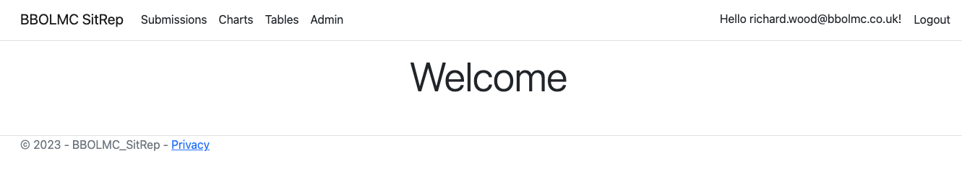

- Click on “Charts”. You will then see a large number of charts pertaining to the data you have submitted. More can be created if you request it from richard.wood@bbolmc.co.uk
- Be aware that only you (and the BBOLMC secretariat who host the project) can see your activity data – not commissioners. We never share a practice’s granular data without their express prior consent. You will have received a data privacy impact assessment which explains this further.
- When you select a chart, you will see BBO-wide data, but you can easily click on different levels (county, place, locality, PCN, and your own practice) to see that data specifically. You can add trandlines. You can overlay your own practice’s data with that of whichever geography you want by selecting more than one level. You will not be able to see PCN-level data unless three or more practices have submitted to it (this is to protect practice confidentiality).
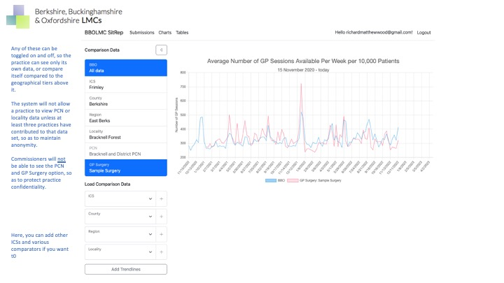

- “Guest users” (normally, selected commissioners on a need-to-know, named basis) will have access to data and will be able to see down to locality level only. They will not have access to PCN or practice-level data. Practices would need to give their express prior consent to this and practices are under no contractual obligation to comply. Commissioners are aware of the confidentiality agreement we have with practices and that this project will not work without trust.

-END-

